**DEPARTMENT OF COMPUTER & SOFTWARE ENGINEERING**

**COLLEGE OF E&ME, NUST, RAWALPINDI**

**Subject Name**

**Digital Signal Processing**

**Lab Number**

**4**

**SUBMITTED TO:**

**LE Sundas Ashraf**

**SUBMITTED BY:**

**Student Name**

1. Wahaaj Nasir

**Reg#413238**

**DE- 44 Dept C&SE**

**Objectives:**

Processing in MATLab

**Related Topic/Chapter in theory class:**

Basics Of Digital Signal Processing

**Hardware/Software required:**

Hardware: PC

Software Tool: MATLab

**Task :**

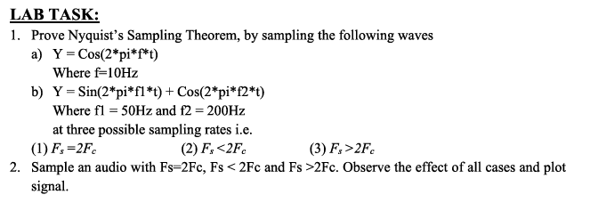

**(1)**

**(a)**

**Solution:**

%%

t = 0:0.01:1;

y1 = cos(2 .* pi .* 10 .* t);

% For y1

fs_1_1 = 20;

fs_1_2 = 5;

fs_1_3 = 40;

t1_1 = 0:1/fs_1_1:1;

t1_2 = 0:1/fs_1_2:1;

t1_3 = 0:1/fs_1_3:1;

y1_1 = cos(2 .* pi .* 10 .* t1_1);

y1_2 = cos(2 .* pi .* 10 .* t1_2);

y1_3 = cos(2 .* pi .* 10 .* t1_3);

subplot(4, 1, 1)

stem(t, y1)

xlabel('Samples')

ylabel('Amplitude')

title('Original Function')

subplot(4, 1, 2)

stem(t1_1, y1_1)

xlabel('Samples')

ylabel('Amplitude')

title('Fs = 2Fm')

subplot(4, 1, 3)

stem(t1_2, y1_2)

xlabel('Samples')

ylabel('Amplitude')

title('Fs < 2Fm')

subplot(4, 1, 4)

stem(t1_3, y1_3)

xlabel('Samples')

ylabel('Amplitude')

title('Fs > 2Fm')

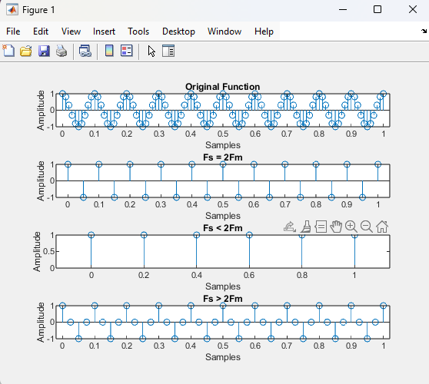

**(b)**

**Solution**

%%

t = 0:0.001:1;

y2 = sin(2 .* pi .* 50 .* t) + cos(2 .* pi .* 200 .* t);

% For y2

fs_2_1 = 400;

fs_2_2 = 200;

fs_2_3 = 800;

t2_1 = 0:1/fs_2_1:1;

t2_2 = 0:1/fs_2_2:1;

t2_3 = 0:1/fs_2_3:1;

y2_1 = cos(2 .* pi .* 200 .* t2_1);

y2_2 = cos(2 .* pi .* 200 .* t2_2);

y2_3 = cos(2 .* pi .* 200 .* t2_3);

subplot(4, 1, 1)

plot(t, y2)

xlabel('Samples')

ylabel('Amplitude')

title('Original Function')

subplot(4, 1, 2)

plot(t2_1, y2_1)

xlabel('Samples')

ylabel('Amplitude')

title('Fs = 2Fm')

subplot(4, 1, 3)

plot(t2_2, y2_2)

xlabel('Samples')

ylabel('Amplitude')

title('Fs < 2Fm')

subplot(4, 1, 4)

plot(t2_3, y2_3)

xlabel('Samples')

ylabel('Amplitude')

title('Fs > 2Fm')

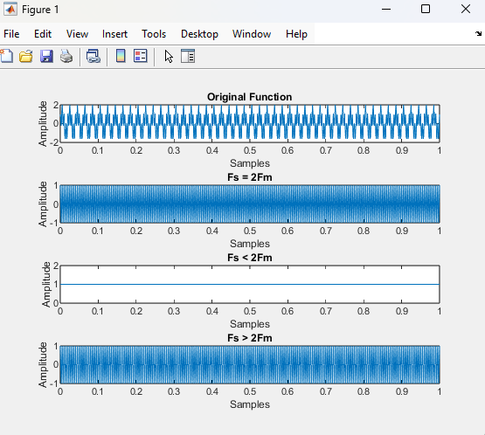

**Task 2:**



**Solution**

%

recorder = audiorecorder(8000, 8, 1);

fs = 8000

disp("Start Recording");

recordblocking(recorder, 2);

disp("Stop Recording");

play(recorder)

myVoice = getaudiodata(recorder);

Fc = fs/2;

eq = Fc * 2;

less = 0.5 * Fc;

more = 4 * Fc;

Fs_equal = resample(myVoice, eq, fs)

Fs_less = resample(myVoice, less, fs)

Fs_more = resample(myVoice, more, fs)

subplot(4, 1, 1)

plot(myVoice)

title('Original')

subplot(4, 1, 2)

plot(Fs_equal)

title('Fs = 2Fm')

subplot(4, 1, 3)

plot(Fs_less)

title('Fs < 2Fm')

subplot(4, 1, 4)

plot(Fs_more)

title('Fs > 2Fm')

sound(Fs_equal)

pause(3)

sound(Fs_less)

pause(3)

sound(Fs_more)

